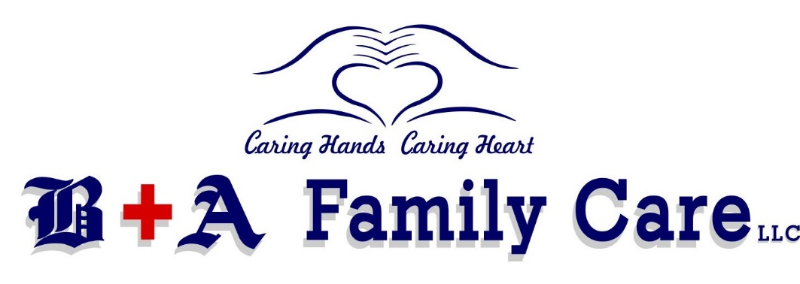

Boaz and Albertville Family Care, LLC
3520 Hwy 431, Suite 100
Albertville, AL 35950
256-849-0500

Notice of Privacy Practices Your Information. Your Rights. Our Responsibilities.
This notice describes how medical information about you may be used and disclosed and how you
can get access to this information. Please review it carefully.
Uses and Disclosures
The following categories describe the different ways in which we may use and disclose your
individually identifiable health information, unless you object:
Treatment. Your health information may be used by staff members or disclosed to other
health care professionals for the purpose of evaluating your health, diagnosing medical
conditions, and providing treatment. For example, results of laboratory tests and
procedures will be available in your medical record to all health professionals who may
provide treatment or who may be consulted by staff members. Additionally, we may
disclose your health information to others who may assist in your care, such as other
healthcare providers, your spouse, your children or parent.
Payment. Your health information may be used in order to bill and collect payment for the
services and items you may receive from us. For example, we may use and disclose your
health information to obtain payment from third parties that may be responsible for such
costs, such as family members. Also we may use your health information to bill you
directly for services and items.
Health care operations. Your health information may be used as necessary to support the
day to day activities and management of Boaz and Albertville Family Care, LLC. For example,
information on the services you received may be used to support budgeting and financial
reporting, activities to evaluate and promote quality, to develop protocols and clinical
guidelines, to develop training programs, and to aid in credentialing medical review, legal
services, and insurance.

Appointment reminders. Your health information will be used by our staff to contact you
and send you appointment reminders.
Information about treatments. Your health information may be used to send you
information that you may find interesting on the treatment and management of your
medical condition. We may also send you information describing other health related
products and services that we believe may interest you.
Law enforcement. Your health information may be disclosed to law enforcement agencies
to support government audits and inspections, to facilitate law enforcement investigations,
and to comply with government mandated reporting.
Release of Information to Family/Friends. Our practice may release your health
information to a friend or family member that is involved in your care, or who assists in
taking care of you. For example, a parent or guardian may ask that a babysitter take their
child for an appointment. In this example, the babysitter or friend may have access to this
child’s medical information.
Patient mass communication. We may use your name and email address(es) and/or text
numbers to contact you with bulk messaging. For instance, to share new promotions for
the clinic, to send clinic newsletters, or to notify you of a physician’s upcoming absence,
such as for vacations.
Other uses and disclosures in certain special circumstances.
• Public Health Risks - (i.e. vital statistics, child abuse/neglect, exposure to
communicable diseases, reporting reactions to drugs or problems with products or
devices.)
• Health Oversight Activities
• Lawsuits and Similar Proceedings – May use or disclose in response to a court or
administrative order, if you are involved in a lawsuit or similar proceeding or in
response to a discovery request, subpoena, or other lawful process.
• Deceased Patients – may be required to release to a medical examiner or coroner.
If necessary, we may also release information in order for funeral director to
perform their jobs.
• Organ and Tissue Donation
• Serious Threats to Health or Safety
• Military - If you are a member of the U.S. or foreign military forces (including
veterans) and if required by the appropriate authorities.
• National Security
• Inmates – Our practice may disclose your health information to correctional
institutions or law enforcement officials if you are an inmate or under the custody of
a law enforcement official. Disclosure would be necessary for the institution to
provide health care services to you, for the safety and security of the institution,
and/or to protect your health and safety or the health and safety of others.
• Worker’s Compensation
Disclosures of your health information or its use for any purpose other than those listed above
requires your specific written authorization. If you change your mind after authorizing a use or
disclosure of your information, you may submit a written revocation of the authorization.
However, your decision to revoke the authorization will not affect or undo any use or disclosure
of information that occurred before your notified us of your decision to revoke your
authorization.
Your Rights
You have certain rights under the federal privacy standards. These include:
● The right to request restrictions on the use and disclosure of your protected health information
for treatment, payment, or health care operations. You have the right to restrict our disclosure to
only certain individuals involved in your care or the payment for your care, such as family
members and friends. We are not required to agree to your request; however, if we do not agree,
we are bound by our agreement except when otherwise required by law, in emergencies or when
the information is necessary to treat you. You must make your request in writing to the attention
of the Privacy Officer. Your request must be described in a clear and concise fashion: a) the
information you wish restricted; b) whether you are requesting to limit our practice’s use,
disclosure or both; c) to whom you want the limits to apply.

● The right to receive confidential communications concerning your medical condition and
treatment
● The right to inspect and copy your protected health information. We will provide a copy or
summary of your health information, usually within 30 days of your request. We may charge a
reasonable, cost-based fee. Our practice may deny your request to inspect and/or copy in certain
limited circumstances; however, you may request a review of the denial.
● The right to amend or submit corrections to your protected health information. This request
must be made in writing and submitted to Privacy Officer with reasons to support your request.
We may deny your request if you ask us to amend information that is in our opinion: a) accurate
and complete; b) not part of the health information kept by or for the practice; c) not part of the
health information which you are permitted to inspect and copy; or d) not created by our
practice, unless the individual or entity that created is not available to amend the information.
We will provide a written explanation for any denial in 60 days.
● The right to receive an accounting of how and to whom your protected health information has
been disclosed. We will include all the disclosures except for those about treatment, payment,
and health care operations, and certain other disclosures (such as any that you asked us to make).
We will provide one accounting a year for free but will charge a reasonable, cost-based fee if you
ask for another one within 12 months.
● The right to receive a printed copy of this notice, even if you have agreed to receive the notice
electronically.
Requests to Inspect Protected Health Information
You may generally inspect or copy the protected health information that we maintain. As
permitted by federal regulation, we require that requests to inspect or copy protected
health information be submitted in writing. You may obtain a form to request access to
your records by contacting your physician and/or privacy officer. Your request will be
reviewed and will generally be approved unless there are legal or medical reasons to deny
the request.

Boaz and Albertville Family Care, LLC
We are required by law to maintain the privacy of your protected health information and to
provide you with this notice of privacy practices. We also are required to abide by the
privacy policies and practices that are outlined in this notice.
Right to Revise Privacy Practices
As permitted by law, we reserve the right to amend or modify our privacy policies and
practices. These changes in our policies and practices may be required by changes in
federal and state laws and regulations. Upon request, we will provide you with the most
recently revised notice on any office visit. The revised policies and practices will be applied
to all protected health information we maintain.
Complaints
If you would like to submit a comment or complaint about our privacy practices, you can do
so by sending a letter outlining your concerns to:
Boaz and Albertville Family Care, LLC
3520 Hwy 431, Suite 100
Albertville, Alabama 35950
If you believe that your privacy rights have been violated, you should call the matter to our
attention by sending a letter describing the cause of your concern to the same address. You
will not be penalized or otherwise retaliated against for filing a complaint.

CREDITS: ATLASMD

